

RURALNET ICT ACADEMY
BUSINESS PLAN
2024

PROJECT AIMED AT PROVIDING ICT EDUCATION TO THE RURAL POPULATION

EXECUTIVE SUMMARY

This business plan describes the opportunities for growth of the Ruralnet ICT Academy as per outlined mission, vision, objectives, business description, marketing and finance. The respective areas are complemented with tables, figures and posters as appropriate. It concludes that the opportunities for bridging the digital gap between rural and urban environment is a viable undertaking.

Table of contents

EXECUTIVE SUMMARY i
Table of contents ii
1.0 CHAPTER ONE 1
1.1 INTRODUCTION 1
1.1.1 Vision Mission Statement 1
1.1. 2 Mission statement 1
1.2 Objectives 1
1.2.1 Short-term objectives 2
1.2.2 Long-term objectives 3
1.2.3 Other objectives 4
1.3 Keys to Success 4
2.0 CHAPTER TWO 7
2.1 DESCRIPTION OF BUSINESS 7
2.1.1 History and Evolution 7
2.2. Location 8
2.3 Organizational Structure 8
2.3.1 Top Management 8
2.3.2 Middle Level of Management 8
2.3.3 Operational Level of Management 9
2.3.3.1 Core Activities 9
2.4 The Problems to Address 9
2.4.1 Our Solution 10
2.5Strategy and Operational Goals 11
2.5.1 Target Market Strategy 11
The following are for fee marketing methods: 12
2.5.3 Sustainable power strategy 13
2.5.5 Sustainable Broadband strategy 13
2.5.6Sustainable Building 14
2.6 Management 14
Duties/Responsibilities: 14
2. Director 14
3. Academy Manager 14
4. ICT instructors 15
5. Administrator 15
Financial Management 16
2.3.1 RICT Academy course roadmap 16
CHAPTER THREE 16
3.0 MARKETING 17
3.1 Introduction 17
Market Analysis Customers 18
3.2. Market Share and Segment 18
3.3. Pricing Strategy 18
3.4. Promotion Strategy 19
3.5. Advertisement 19
3.6. Efficiency in Work 19
3.7. Good Public Relation 19
3.8. Distribution Strategy 19
3.9. Sales Tactics 19
CHAPTER FOUR 20
4.0. FINANCES 20
4.1. Introduction 20
4.2. Start-Up Expenses 20
4.3 Start-up Capital 22
4.4 Determining Start-Up Capital 23
4.5 Cash Flow 24
4.5 Profit and Loss statement 27
Valuable Costs 29
BREAK EVEN POINT OF 2026 29
BREAK EVEN POINT OF 2025 29
FINANCIAL RATIO SALE MARGIN 30
5.0 CONCLUSION 31
Certificates 32
Marketing Samples 33

1.0 CHAPTER ONE: INTRODUCTION

1.1 Background

Ruralnet ICT Academy (RICT) is an ongoing project aimed at providing ICT education to the rural population located in Siaya County in a town called Ugunja along Busia-Kisumu highway. The Academy aims to bridge the digital divide between rural and urban areas by offering high-quality training to the rural population. The Academy offers a range of courses, including computer basics, web design, programming and digital marketing.

Computer training services, as shown in our plan, have an excellent profitability level and growth rate. Our competitive edge along with new training techniques puts RICT at the forefront of training services. We are living in an age where computer knowledge is a must and the market for computer training services is booming.

Our training center will differ from the traditional computer training services usually offered by colleges and universities because of our added personal touch and premium resources.

1.1.1 Vision
Ruralnet ICT Academy’s (RICT) vision is bridging the digital gab between the rural and urban areas.

1.1. 2 Mission statement
RICT’s mission is to understand what our students and businesses hope to achieve and dedicate our computer training and development to the fulfillment of those goals.

The computer training provided is contributing visibly and substantially to the fulfillment of our area business's strategies.

RICT will maintain financial balance, charge a value for our services, and deliver an even higher value to our clients. RICT will make computer user techniques accessible to hundreds of computer users who would otherwise not have the updated knowledge to use them. RICT will make a profit and generate cash.

The Academy will provide a rewarding work environment and fair compensation to our employees; ultimately provide excellent value to our customers and a fair return to our owners.

1.2 Objectives
The Ruralnet ICT Academy (RICT) knows firsthand that computer training has to meet all of its customers' needs in order to have a tangible lasting impact. When you measure across multiple customer segments—each of which has its own priorities—you see how much more training must do to consistently and simultaneously satisfy participants, managers, and executives. Training then can move to close those gaps and deliver more real value. Closing those gaps between employer skill needs, employee and learner skills development is the main objective of RICT.

1.2.1 Short-term objectives
- To meet the computer training needs of computer users and area businesses by way of Skill Assessment and Goal-Based Training.
- Enhance network provision by installing a better system which can increase bandwidth rate and extent of coverage.
- Retain new and current students through Step-Level Based computer training.
- Increase high skill level record improvements by re-assessing students upon completion of computer training.
- Aim to the highest skill delivery performance in the area through tracking new employment or computer-related improvements by monitoring outcomes of student completions after a 30-day period.
- Adjust the computer training program as needed and according to outcomes.
- Continue to assess our own staff's computer training skill level and effectiveness.
- Acquire a room that will be an extension to the available room. Rural Net ICT Academy will conduct computer services in the newly acquired room. The new room must be equipped with materials after partitioning. The equipment includes; furniture, printer, photocopying machine, electrical equipment, laptops, etc. The Quotation for the required resources is as provided in Table 1.1.

Table 1.1: Quotation of required resources
S/No | Item | Quantity | Cost (Ksh)
1 | Client Router | 1 | 2,000
2 | Rj45 network cable | 2 | 1,000
3 | Padlock | 2 | 1,000
4 | Standing banner | 1 | 800
5 | Banner | 4 | 300
6 | Counter book | 2 | 300
7 | Executive blue pen | 2 | 100
8 | White board | 1 | 1,500
 | Total (Ksh) |  | 7,000

However, Ruralnet ICT Academy has some of the required resources to equip the new room to start off with as presented in Table 1.2

Table 1.2: Required resources for new room
S/No | Item | Quantity
1 | Office chairs | 5
2 | Conference table | 1
3 | Laptops | 4
4 | Display screen | 1
5 | Fridge | 1
6 | Cabinet | 1
7 | Laptop chargers | 4
8 | Projector | 1
9 | Printing papers (assorted) | 5 reams

1.2.2 Long-term objectives
- Identifying a larger building and buying it for larger accommodation of students and other computer services within Ugunja town, since RICT is known all over as an institution based in the town. The premise must have a larger hall which will serve the purpose of accommodating all students acquiring basic computer skills (Introduction to computers, Microsoft office suit applications, internet and basic networking), rooms for students learning programming, networking, graphic designing, data science and analysis, and accounting courses; each course with its own room. Another room will be for computer facilities and maintenance such as repair and software development.

- Opening branches in other places such as Kisumu, Ukwala, Sega, Bumala and Busia. Before settling in these places, a pre-visit must be taken for survey to identify the security of the region, competitors and the risks that might arise upon establishment of RuralNet branches. Once peace and ample learning environment is identified, RICT will identify the best strategic buildings with accommodative rooms for learning and performing other computer services. The expansion or opening of RICT branches will not take place once at the mentioned towns, but one after another. Upon settlement, qualified business personnel with marketing skills will be sent to the town, nearby schools and facilities to create awareness and impart the importance of computer technological skills gained from RuralNet ICT Academy.

- After registering with Kenya Examination bodies such as KASNEB, CBET, and KNEC, RuralNet ICT Academy will introduce other courses such as accounting, business, social work and environmental, which will make RICT to be not only a computer school, but will be a school of ICT and Social Studies. This will closely be followed by employment of skilled instructors, which will coach the learners in the above courses.

- Ruralnet ICT Academy also aim to introduce software development, data management and analysis, and hardware repair sector. Ugunja town and Siaya County has a number of mobile software developers who do not have permanent offices to operate from, yet most client who needs their data to be managed and software and websites to be maintain needs an office or a company. RuralNet has seen this as an advantage, therefore, should it have such a sector, it will employ skilled persons in the area.

- RuralNet ICT Academy will continuously strive to improve its curriculum, teaching methods, and facilities to keep up with the rapidly evolving field of technology. This involves regularly reviewing and updating courses, incorporating new technologies and tools, and seeking feedback from students and industry partners. These long-term objectives are aimed at ensuring that RICT provides its students with a strong foundation in computer science and prepares them for successful careers in the technology industry.

- RuralNet ICT Academy also has a goal of provision of suitable and stable solar energy as an on option for the surrounding business premises in case there is power outages. This system also preserves the environment since it offers clean and safe energy.

1.2.3 Other objectives
    - Skill Development: Enhancing students' technical skills in areas like programming, software development, hardware management, or digital design.
    - Problem-Solving: Encouraging students to solve real-world problems using technology, fostering critical thinking and creativity.
    - Collaboration: Promoting teamwork and collaboration among students as they work together on different aspects of the project.
    - Project Management: Teaching students project planning, time management, and organization skills, which are valuable in various careers.
    - Application of Theory: Enabling students to apply theoretical concepts learned in the classroom to practical scenarios.
    - Presentation Skills: Developing communication skills by requiring students to present their project to the class or peers.
    - Innovation: Encouraging students to come up with innovative ideas that push the boundaries of technology and its applications.
    - Hands-on Experience: Providing students with hands-on experience with technology tools and equipment.
    - Portfolio Building: Creating a portfolio of projects that students can showcase to potential employers or educational institutions. (opening RICT branches in other places being the major project).
- Exposure to Emerging Technologies: Introducing students to emerging trends in the ICT field, preparing them for future industry developments.

1.3 Keys to Success
RICT's keys to success include: implementing an effective cash flow plan, achieving efficiency, running our training like a business, and maintaining a serious business discipline to everything in our training.

RICT's cash flow plan is to:
- Maintain enough money on hand each month to pay the cash obligations the following month.
- Identify and eliminate deficiencies or surpluses in cash.
- Maintain a good record of cash flow and setting limits in expenditure in order to enable us to sustain the daily running of business activities even in times when the profits are extremely low.
- Alter business financial plans to provide more cash if deficiencies are found.
- Invest any revealed excess cash in an accessible, interest bearing, low-risk account, such as a savings account.
- Eliminate credit and terms to customers.
- Clearly understand the computer training market, distributions costs and competition, and continually adjusting accordingly.
- Keep enough cash, as an added cushion for security, on hand to cover expenses.
- Reduce accountant expenses by producing our own summary statistics and projections.

To achieve effectiveness RICT will:
- Link our training and development to business strategy by understanding what our customers hope to achieve and dedicating training and development to the fulfillment of those goals.
- Focus on business issues rather than training content by working tirelessly to offer training that matches new and emerging demands.
- Let our customer demand shape our training and development offerings by providing a core curriculum designed to train individuals in basic skills and core competencies. We will also conduct ongoing needs assessments across the organization aimed at making training more strategic and providing training that has more business impact.
- Clarify our training and development business mission by avoiding trying to be all things to all people. RICT will offer more than training to develop employee skills. The training RICT will provide will also contribute—visible and substantially—to fulfillment of our customers' business strategies.
- See training and development as an enterprise, not as a function by maintaining intense focus on our customers, their issues, and their needs; and being systematic in our efforts to meet those needs efficiently, consistently, and reliably.
- Daring to pursue missions that are linked to the business strategy and focused on business issues; willingly tackling big challenges, even those that are difficult and risky; being ambitious, alert, confident, and pragmatic.

To achieve cost efficiency, Ruralnet ICT Academy will:
    - Expose hidden costs for businesses by allowing them to see their "true" training costs such as lost productivity, wasted training investments, or lost opportunity. Teaching these businesses how to measure training costs, and what they are getting back from their training.
    - Aggressively reduce costs by eliminating duplication.
    - Build and maintain reliable systems and processes by putting reliable training and development systems and processes in place.
    - Operate as a variable cost, not a fixed expense, by understanding that customers spend only at their own initiative. Making training a variable cost makes especially good sense now that the pace of change in business—and the resulting demands for learning-are accelerating so dramatically. We found that there's no better stimulus to innovate, improve, and become more efficient than having to earn the right to serve customers, each and every day.
    - Be flexible and opportunistic in sourcing by strategically linking and focusing on business issues, allowing customers to consistently define the value derived from the training. Clarify precisely what our customers expect from the training; negotiate a results contract; guarantee customer satisfaction.

To maintain a serious business discipline RICT will:
- Continually adapt to ongoing change in the business environment.
- Promote learning not as an ideal but as a way to fulfill specific business- driven objectives.
- Be entrepreneurial-live with risk.
- Structure training to provide exactly what is needed.
- Divide customers into segments and provide each segment appropriate forms of value.
- Document customers' expectations.
- Write results contracts specifying value to be delivered, at what price, customers' role in achieving targeted results.
- Offer service guarantees.

2.0 CHAPTER TWO: DESCRIPTION OF BUSINESS

2.1 History and Evolution

In 2010, Micha Schraven and Lawrence Odongo worked together on a large ICT project in the Sega region. They were both driven by a shared interest in ICT and rural development. In December 2016, they founded the RuralNet Internet Services Provider and IT Academy with the use of the MacBook pro’s that were donated by Service Now. Over time, RuralNet has evolved and is designed to be a social enterprise that is both an Internet Services Provider (ISP) and an associated ICT Academy to interest groups in Kenya’s country side and beyond. RICT Academy advances the communities it operates in through the facilitation of sustainable, quality ICT services and network facility. This is an area that is typically deprived of basic IT resources (Typically IT Students have no computers, internet and electricity). The Academy also has a goal of provision of suitable and stable solar energy as an option for the surrounding business premises, in case there is power outages. This system also preserves the environment since it offers clean and safe energy.

At inception, the Program was developed for the purpose of providing basic computer training to the rural area residents and primary schools. The training was provided per 2-hour session. Upon completion of the program, the students received a Certificate. The sessions were made up of 10 core areas of Microsoft Office® training. The core areas were:
    - Word Processing
    - Access Database
    - Publisher
    - Internet
    - Excel spreadsheets
    - Presentations
    - Graphics design
    - Networking
    - Accounting
    - Data analysis
    - Programming

Location
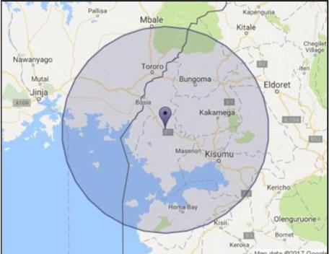

RICT is located on the second floor of Oguya Plaza. Doting Ugunja Town is RuralNet ICT Academy; a jewel that is nestled besides Well-Oil B Petrol Station, with lushly designs complete with MECA national full security (Fig. 2.1).

Currently, it operates from one hall partitioned into two rooms with a total surface area of 50 m². i.e., class and office.
Figure 2.1: Location of the premise

Source: https://earth.google.com/web/search/RURALNET+UGUNJA/@0.1795474,34.2980928,1258.88976945a,1056.53652078d,35y,0h,0t,0r/data=CigiJgokCbF8OiyAj8o_EYagUp3_Usc_GVvoxe_mKEFAI

Organizational Structure
RuralNet ICT Academy is organized into a hierarchy with top, middle and operational management levels. The company has various departments which assist in the delivery of quality services to the clients.

2.3.1 Top Management
This level of management consists of an organization’s chief executive or managing director. It is the ultimate source of power and authority, since it oversees the goals, policies, and procedures of the company. Some roles and responsibilities of the top management can be summarized as follows:
- Laying down the objectives and broad policies of the business enterprise.
- Issuing necessary instructions for the preparation of department-specific programs, schedules, and procedures, among others.
- Preparing strategic plans and policies for the organization.
- Appointing the employees for middle-level management, i.e. Departmental managers.
- Establishing controls of all organizational departments. Strategic planning and execution of the overall business success.

2.3.2 Middle Level of Management
The Departmental managers form this middle management level. These people are directly accountable to top management for the functioning of their respective departments, devoting more time to organizational and directional functions. Some of their roles are;
- Executing the plans of the organization in accordance with the policies and directives laid out by the top management level
- Forming plans for the sub-units of the organization that they supervise
- Participating in the hiring and training processes of lower-level management.
- Interpreting and explaining the policies from top-level management to lower-level management.
- Sending reports and data to top management in a timely and efficient manner.

2.3.3 Operational Level of Management
This level consists of operational employees whose job is to complete tasks assigned by the manager. They include ICT instructors, Technicians and marketing personnel.

2.3.3.1 Core Activities
RuralNet academy started as an Internet Service Provider (ISP) to explore revenue generating activities. In February 2017, its Academy became accredited as an official training institute. Table 2.1 presents Ruralnet ICT Academy’s activities and time of establishment.

Table 2.1: Core Activities
Activity | Purpose | Established
Internet Service Provider (ISP) | Revenue generator | December 2016
ICT Academy | ICT Training | April 2017
Advanced computer courses | ICT Training | January 2019
KASNEB and CPA courses | Exam Centre | January 2020
Transition to Star link Internet | High speed internet | January 2025
College Centre for ICT | ICT training | January 2030 (planned)
Skills and Talent incubation center | Capacity building | January 2030 (planned)

2.4 The Problems to Address
Almost half of the countries in Africa have a mobile phone. This divide is larger when it comes to gaining access to the internet. The International Telecommunication Union (ITU), reckons that 54% of Kenyans do not yet use the internet, compared to just 11% of the Western countries (Figure 2.1). The use of internet is constrained by a number of factors, namely:
- Facts and numbers.
- Teen age pregnancies.
- High dropout rate.
- Regional unemployment.
- Power outages.
- No broadband.

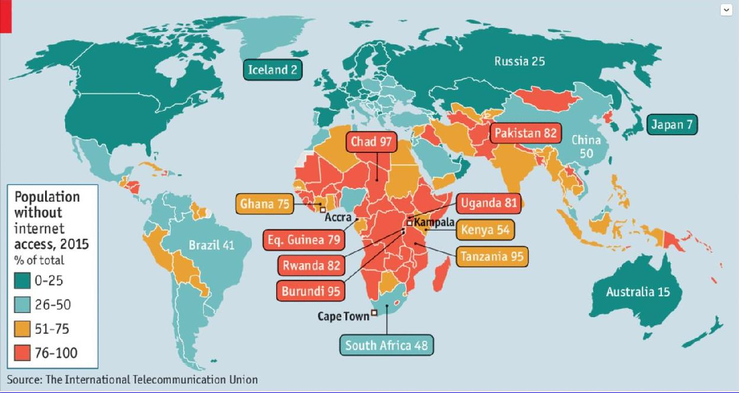
Figure 2.2: Population without internet access

2.4.1 Our Solution
The global ICT industry is continually going through significant world changing transformations. The recent shift from the capital-intensive hardware and software production to services-oriented models with extensive social media integration, has provided ground for small and medium startups to disrupt dominant industries (Uber, AirBNB, Facebook, and Service Now). This is the time where the successful execution of a great idea can change the world.

Kenya's young, educated human resource with competitive labor costs, have been the main success factors that contributed towards the growth of ICT sectors in Sub-Saharan African countries. We believe there is a brain drain as well as higher educated folks will migrate, a problem we address by providing business opportunities.

The companies in the region, most of which are small and Medium-sized Enterprises (SMEs), face global competition by several times bigger outsourcing destinations such as India, China, Russia and others. Even so, there are important opportunities for Kenya that did not exist until very recently, like the opportunity for small and new entrepreneurs to invent and globally market new technologies, based on universal problems they will solve domestically.

Kenyan technology hubs, where startups cluster their powers in shared office space are producing promising companies and therefore, attract international attention (Hub, ilab). We envision a significant economic opportunity for the East African countryside to improve the IT curriculum with relevant universally demanded skills. To seize business opportunities with relevant cheap labor and to add value to our local organizations, and by doing so, becoming an accelerator to the local economy.

2.5 Strategy and Operational Goals

2.5.1 Target Market Strategy
Ruralnet ICT Academy (RICT) will focus on the highlighted segments. These segments are more interesting than other groups because they have the specific computer training needs, which RICT intends to meet.

      - Microsoft Training for different Institutions employees.
      - Training clients on realty software and basic Windows and Microsoft Office software.
      - Training clients on basic desktop publishing skills, scanning color photos, creating flyers for property, etc.
      - Training physicians in specific specialties to use their patient management software.
      - Training people on how to get the most from the Internet.
      - Training business people on how to keep up with their websites, from e - mail management to web page creation.
      - Training office personnel on how to use Microsoft Office or other office packages.
      - Training the first-time computer owner on how to use their home PC.
      - Setting up newsletter templates and teaching businesses how to keep up with the in- house or Institutional newsletter.
      - Training sales officials on how to use database software to track their sales and marketing functions.
      - Training individuals who are looking for better employment on how to use the latest software packages.
      - Training clients on how to use Macintosh Operating System.

These strategies are most effective when put into a formula in the following order:

- Identifying the symptoms
- Diagnosis of the problem
- Prognosis
- Treatment
- Follow-up/Outcome Management

Additional Target Marketing Strategies
Our slogan "For smart and sharp IT trainings" emphasizes one of our major benefits and we will use this slogan throughout our literature, advertising, and graphics.

The following functions will be assigned to our marketing tools:
  - Get name recognition.
  - Obtain leads.
  - Turn qualified prospect into a customer.
  - Ensure customer loyalty.
  - Stimulate training Center traffic.
  - Sell service directly.
  - Introduce new service.
  - Sell a special service package.

The following are low cost/no cost marketing methods:
  - Form relationships with noncompeting businesses.
  - Get to know other computer professionals.
  - Combine services in virtual corporations to provide turnkey solutions to clients.
  - Do cooperative mailings with other non-competing professionals.
  - Volunteer to speak in clubs, associations, workshops, or seminars on our specialty.
  - Periodically ask customers for referrals.
  - Join a barter exchange.
  - Produce a periodic newsletter.
  - Write articles for local newspapers or upload them to Internet bulletin boards.
  - Join Internet newsgroups and mail lists.
  - Submit press releases.

The following are for fee marketing methods:
  - Join associations.
  - Conduct seminars.
  - Conduct contests.
  - Offer freebees.

RICT has two marketing Approaches in place and they are:
Approach #1:
- Get a list of companies together that we think may need our services (such as new businesses from the County Clerk's office).
- Call these people and find out the contact person and if they need our services.
- Mail a letter, brochure, and card to the interested companies.
- Follow-up with another call to the contact person.
- Continue to call these people periodically.
- Keep good records of companies and contact logs.

Approach #2:
- Get a list of companies together that we think may need our services (such as new businesses from the County Clerk's office).
- Call these people and find out the contact person and if they need our services.
- Ask them if they would like a FREE subscription to our computer newsletter that we will fax them periodically.
- Fax the newsletter to those who are interested, and include mail enrollment information as well. Mail information to those people who do not want newsletters but are still interested in our services.
- Follow-up in a week to see what they thought and if we can help them with anything.
- Continue to send our fax newsletter regularly.
- Keep good records of contacts and logs.

2.5.2 Other Strategies
- Join Learning Exchange resource database that will promote our training to employers, workers, and life-long learners via the Internet.
- Create alliances with grassroots organizations and staffing organizations.
- Assist in job placement upon completion of Certification testing.
- Create website for schedule information, applications, and book purchasing.
- Network amongst family and friends by "word of mouth" opportunities to gather referrals.
- Contact students from previous classes.

2.5.3 Sustainable power strategy
RuralNet operates in a remote location where power outages are frequent. Numerous power outages seriously affect business continuity and Ruralnet customers were also affected. Therefore, RuralNet has considered the available solutions and found that a combination of grid power, UPS backup and Solar generated electricity offer the most economical and sustainable solution.

In 2019, the facility was provided with a solar power system, which allows us to guarantee continuous services to our customers.

2.5.5 Sustainable Broadband strategy
Internet is currently provided through a microwave connection at a rate of US$100 per Mbps. The service providers are presented in Table 2.2.

Table 2.2: Sustaining Internet service

Provider | Type | Cost per Mbps ( ) | Speed | Availability | Customer Support
Safaricom | Microwave | US$100 | 1-5 Mbps | High | Good
Liquid telecom | Fiber broadband | US$100 | 2-10 Mbps | Ceased operations | Unreliable
Airtel | Scratch card or mobile subscription | N/A | 40 Mbps | High | Good
Safaricom mobile | Scratch card or mobile  subscription | N/A | 40 Mbps | High | Good

2.5.6 Sustainable Building
Building Facility is a well-established, secure and accessible. RICT now two private offices for learning and aspire to have a modern conferencing hall.

2.6 Management
- Board Member

Duties/Responsibilities:
  - Duty of Care: Ensuring all assets are used prudently.
  - Duty of Loyalty: Ensuring all decisions are made in the best interests of the organization and help it move closer to its mission.
  - Duty of Obedience: Ensuring the organization abides by all laws and regulations, as well as its own By-laws.
  - Strategic governance and oversight.
  - Serving the organization’s stakeholders.
  - Managing budgets.
  - Setting policies.
  - Overseeing personnel.
  - Setting goals.
  - Measuring goals and achievements.

Director
Supervisory Responsibilities:
- Oversees the daily activities of training associates and consultants.
- Conducts performance evaluations that are timely and constructive.

Academy Manager

Duties/Responsibilities:
- Reviews existing training programs; suggests enhancements and modifications to improve engagement, learning, and retention and/or to meet the changing needs of clientele, the organization, or the industry.
- Ensures that training materials and programs are current, accurate, and effective.
- Maintains knowledge of new methods and techniques for training, and training requirements applicable to the organization and/or industry.
- Identifies problems and opportunities such as operational changes or industry developments that training could improve.
- Conducts or facilitates required and recommended training sessions.
- Collaborates with vendors and third-party training providers to arrange employee registration for and participation in outside training programs.
- Ensures that training milestones and goals are met while adhering to approved training budget.
- Prepares and implements training budget.
- Performs other related duties as assigned.

ICT instructors
  - Design, facilitate and teach the computer instruction component.
  - Assess, supervise, and motivate students.
  - Evaluating student work and progress.
  - Prepare and execute lesson plans.
  - Develop course syllabus,
  - Assigning tasks

Administrator
- Manage budgets, logistics and events or meetings.
- Handle scheduling, record-keeping and reporting.
- Ensure the school complies with relevant laws and regulations.
- Develop and run educational programs.
- Hire, train and advise staff.
- Counsel students when needed.
- Resolve conflicts and other issues.
- Communicate with parents, regulatory bodies and the public.
- Have a hand in the creation of the school curriculum.
- Implement actions that improve the school and the quality of education (e.g. building renovations, new guidelines for students, new subjects).
- Help shape and uphold the vision of the school.
- Check for any information in the institution’s communication channels such as messages and managing incoming/outgoing messages.
BOARD
MEMBERSS

FINANCIAL MANAGER

ACADEMY MANAGER
DIRECTOR

ADMINSTRATOR
ICT INSTRUCTOR

Figure 2.3: Organizational Chart

Financial Management (Financial Manager)
Ruralnet will hire a teacher with administrative skills to manage the ledger. We project administrative and operational costs at full capacity to be about Ksh. 5.4 million as presented in Tables 2.3 and 2.4.

Table 2.3: Staff remunerations rates and total amount per year
No | Item | Units | Rates  (Ksh) | Amount per  Month (Ksh) | Per year  (Ksh)
1 | ITC Instructors | 2 | 25,000 | 50,000 | 600,000
2 | Administrator | 1 | 30,000 | 30,000 | 360,000
3 | Accountant | 1 | 30,000 | 30,000 | 360,000
4 | Manager | 1 | 50,000 | 50,000 | 600,000
5 | Office assistant | 1 | 15,000 | 15,000 | 180,000
6 | Security officer | 1 | 12,500 | 12,500 | 150,000
7 | Office rent | 1 | 20,000 | 20,000 | 240,000
8 | Internet | 1 | 20,000 | 20,000 | 240,000
Annual total (Ksh) |  |  | 202,500 | 227,500 | 2,730,000

Table 2.4: Organizational overhead, operational, and projected revenue
Item | Amount (Ksh)
 | Monthly | Yearly
Overhead | 10,000 | 12,000
Operational cost | 230,000 | 2,760,000
Projected revenue | 22,000 | 2,640,000
Total (Ksh) | 262,000 | 5,412,000

RICT Academy course roadmap
      - 2017: Internet basics, Apple, Windows, Office.
      - 2018: Seeking addition of Cisco networking courses.
      - 2022: Conducting wide advertisement for better awareness.
      - 2025: Introducing other courses such as finance.
      - 2030: Opening branches in the nearby towns such as Yala and Busia.

CHAPTER THREE: MARKETING

Introduction
Ruralnet uses several ways to get in touch with potential students, customers and partners or clients, who may be categorized as local, regional and international as presented in Figure 3.1. The ways include but not limited to:
    - Distributing fliers/brochures to local people and giving business cards with details to clients.
    - Community outreach. This we achieve by sending officials to the churches and groups during their meeting to create awareness to the crowd, organize events such as workshops, seminars and training programs.
    - Partner with local organizations, schools and colleges to reach out to a wider audience.
    - Local Street: use of banners and posters.
- Regional: use of social media sites such as Facebook, Instagram and X(twitter), TikTok and multimedia such as radio stations and Television channels.
    - International: website, social media sites.
    - Referral marketing, word-of-mouth is a powerful marketing tool, especially in rural areas by offering incentives to current students who refer new students and their families. RICT can offer discounts.
    - Content marketing, creating high-quality content such as blog posts, videos and tutorial that provide valuable information to potential students.
- Strategic partnership, especially with local business, government agencies and NGOs to offer new courses and services. For example, local government agency to offer digital literacy training to farmers.
- Branding, this is crucial for promoting RICT, creating a professional image, improving team morale, and differentiating from the competition. Branded items will be pens, shirts, mug, even exercise books that can be charged inclusively from fee.

Potential clients
2017 2018 2020 2021 2022
P O T E N T I A L C U S T O M E R S
N E W H O M E
N E W B U S I N E S S

Figure 3.1: RICT’s potential clients

Market Analysis Customers
6%
15%
28%
10%
15%
10%
3%
20%
22%
About 65% of the customer are the residents of Ugunja constituency. About 20%, are from nearby towns where they travel from various parts searching for goods and services. Other customers will include institutions like hospitals and schools that will need our services such as network installation and ICT training (Figure 3.2).

other
13%
30%
57%
Figure 3.2: Customer’s residence

3.2. Market Share and Segment
Most of the proprietors/customers come who come from Ugunja constituency, Siaya County at large and the surrounding area, seek for our products and services such as smart IT center with better environment for learning and network provisions as shown in Figure 3.3.



Discount 20%

55%
Fig 3.3: Market share and segments

Pricing Strategy
The business management ensures that advanced courses are highly priced (not too high, but affordable price, which favors the interested learners). Those spending more learning hours or want crush programs price shall be slightly lifted. Any charges affecting the running of the business are eliminated as soon as it is discovered. In case of any increase in price of commodities from the suppliers, the business will automatically change to another supplier who is at least cheaper.

Promotion Strategy
For the business to grow, there must be means of promoting the business. The methods in which the business enterprise uses to promote its business is through; advertisements, good public relation, efficiency in work and offering extra services after computer basic course; e.g. how to install software and networking procedure both theoretically and practical.

Advertisement
Advertisements are done through offering business cards to people who will be around the enterprise and customers after purchasing their products. The card will have the business name, address, its location and contact to enable easy access. Social media platforms such as broadcasting channels, Facebook, WhatsApp, twitter, Instagram and YouTube shall the business also use to advertise. Online sessions shall be conducted for distant learners who are interested.

Efficiency in Work
The business ensures that the planned activities are completed in time and the promises to the customers are adhered to, this will gain trust from clients and mostly prevent conflict.

Good Public Relation
This method will be used to attract more customers. Clients will be handled well and also get assistance when in need of, respect among employees will be encouraged since this will make good working condition within the business premises and establish peace.

Distribution Strategy
RuralNet is situated in a strategic position to enhance distribution of the services. In case of institutions and schools, the ICT instructor uses motorbike, to reach the learners, later the management will buy a van which will be used to reach clients who are in groups in their places of work such as schools or organizations to deliver IT skills to them.

Sales Tactics
RuralNet ICT academy uses direct method of delivering services where most learners attend tutorial sessions by themselves. The prominent institutions who want their employees to get the skills will be given the knowledge at a discount. Other companies will be given services in credit, which will be paid at the end of the month. (Networking). Ruralnet also plans to give discounts to customers at specified periods to encourage more people.

4.0 CHAPTER FOUR: FINANCES

4.1. Introduction
This Chapter presents tabulated information, which include: Start –Up expenses; Determine Start-Up Capital; Cash Flow; Income Projection Statement; Profit and Loss Statement; Balance Sheet and Milestone.

4.2. Start-Up Expenses
Start-Up Expenses, include all items that are important and necessary to support the business activities, these are as shown in Table 4.1.

Table 4.1: Start-up capital

Particular | Amount (Ksh)
Business Licenses | 5,800
Incorporation Expenses | 54,000
Deposits | 0
Bank Account | 0
Rent | 20,000
Interior Modifications | 50,000
Total (Ksh) | 129,800
Equipment/Machinery required

Laptops | 2,000,000
Laptop chargers | 200,000
Electric extensions | 1,200
Mouse | 5,000
Keyboards | 10,000
Office desk | 15,000
Office chair | 8,500
Plastic chairs | 5,000
Tables | 25,000
Printer | 30,000
Total Equipment/Machinery | 2,283,200
Others
Insurance | -
Stationery/Business Cards | 6,500
Brochures | 890
Pre-Opening Advertising | 25,800
Opening Inventory | -
Total Startup Expenses (Ksh) | 2,446,190

  - Balance Sheet
Current Assets and Liabilities
A liability is a financial obligation or debt that a company owes to others, such as creditors, suppliers, or employees.
Assets, on the other hand refer to resources owned by an individual or business that have economic value and can provide future benefits. In accounting, assets are typically recorded on a company's balance sheet and are classified into various categories based on their liquidity, usage, and lifespan.

Table 4.2: Assets and Liabilities

Assets | Amount (Ksh).
Current Assets: | 2,484,266
Cash: | 12,670
Petty Cash | 106,200
Accounts Receivable
Inventory | 240,840
Short-Term Investment | 150,000
Prepaid Expense
Long-Term Investment | 204,000
Total Assets: | 3,311,646
Liabilities
Current Liabilities:
Accounts Payable | 0
Notes Payable | 0
Interest Payable | 0
Taxes Payable:
Federal Income Tax | 0
State Income Tax | 0
Self - Employment Tax | 12,500
Sales Tax (SBE) | 21,050
Property Tax | 3,840
Payroll Accrual | 0
Long-term Liabilities | 0
Notes Payable | 0
Net-Worth /Owner’s Equity /Retained earnings | 125,490
Total Liabilities (Ksh.): | 162,880

4.4 Start-up Capital
Start-Up Capital entails the amount RICT is supposed to use for a period of 12 months as presented in Table 4.3.

Table 4.3: Start-up Capital

Category | Month
 | 1 | 2 | 3 | 4 | 5 | 6 | 7 | 8 | 9 | 10 | 11 | 12
Starting cash | 0.00 | 10425 | 20946 | 62535 | 159440 | 156373 | 155832 | 164775 | 175585 | 193198 | 201288 | 208321
Cash In:
Cash Sales Paid | 32000 | 25000 | 57930 | 53895 | 93380 | 15800 | 17895 | 25235 | 25000 | 40000 | 29990 | 10495
Receivables | 20180 | 25580 | 15890 | 69530 | 15580 | 9800 | 11250 | 8345 | 16555 | 2150 | 10000 | 15400
Total Cash In | 52180 | 50580 | 73820 | 123425 | 24918 | 25265 | 29145 | 33580 | 41555 | 42150 | 39990 | 25895
Cash Out:
Rent | 17000 | 17000 | 17000 | 17000 | 17000 | 17000 | 17000 | 17000 | 17000 | 17000 | 17000 | 17000
Payroll | 320 | 328 | 320 | 320 | 320 | 320 | 320 | 328 | 320 | 320 | 320 | 328
Other
Total Cash Out | 41755 | 42214 | 27085 | 26520 | 27985 | 25806 | 20205 | 22770 |  | 23942 | 34060 | 22957
Ending balance | 10425 | 20946 | 62535 | 159440 | 156373 | 155832 | 164775 | 175585 | 193198 | 193198 | 201288 | 208321
Change (cash flow)-Ksh. | 10,425 | 20,946 | 62,535 | 159,440 | 156,373 | 155,832 | 164,775 | 175,585 | 193,198 | 193,198 | 201,288 | 208,321

4.5 Determining Start-Up Capital
The determinants of Start-up cash are as presented in Table 4.4

Table 4.4: Determining startup capital

Determinant | Month
 | 1 | 2 | 3 | 4 | 5 | 6 | 7 | 8 | 9 | 10 | 11 | 12
Starting cash | 0.00 | 10425 | 20946 | 62535 | 159440 | 156373 | 155832 | 164775 | 175585 | 193198 | 201288 | 208321
Cash In:
Cash Sales Paid | 32000 | 25000 | 57930 | 53895 | 93380 | 15800 | 17895 | 25235 | 25000 | 40000 | 29990 | 10495
Receivables | 20180 | 25580 | 15890 | 69530 | 15580 | 9800 | 11250 | 8345 | 16555 | 2150 | 10000 | 15400
Total Cash In | 52180 | 50580 | 73820 | 123425 | 24918 | 25265 | 29145 | 33580 | 41555 | 42150 | 39990 | 25895
Cash Out:
Rent | 17000 | 17000 | 17000 | 17000 | 17000 | 17000 | 17000 | 17000 | 17000 | 17000 | 17000 | 17000
Payroll | 320 | 328 | 320 | 320 | 320 | 320 | 320 | 328 | 320 | 320 | 320 | 328
Other
Total Cash Out | 41755 | 42214 | 27085 | 26520 | 27985 | 25806 | 20205 | 22770 |  | 23942 | 34060 | 22957
Ending Balance | 10425 | 20946 | 62535 | 159440 | 156373 | 155832 | 164775 | 175585 | 193198 | 193198 | 201288 | 208321
Change(cash flow) | 10,425 | 20,946 | 62,535 | 159,440 | 156,373 | 155,832 | 164,775 | 175,585 | 193,198 | 193,198 | 201,288 | 208,321

4.5 Cash Flow
Table 4.5 presents RICT’s cash flow trends over a period of 12 months.

Table 4.5: Cash flow

Months | 1 | 2 | 3 | 4 | 5 | 6 | 7 | 8 | 9 | 10 | 11 | 12
Starting cash | 201236 | 235181 | 277717 | 332322 | 488397 | 498242 | 534986 | 572431 | 598711 | 619014 | 624486 | 693714
Cash In:
Cash Sales | 76575 | 34700 | 40500 | 103195 | 25530 | 24375 | 25530 | 21650 | 20100 | 18800 | 44775 | 41500
Receivables | 16795 | 50050 | 41190 | 79400 | 12300 | 38175 | 31120 | 27400 | 24145 | 20732 | 47410 | 31945
Total Intake | 93,370 | 84,750 | 81,690 | 18,2595 | 37,830 | 62,550 | 57,650 | 49,050 | 44,245 | 39,532 | 92,185 | 73,445
Cash Out (expenses):
Rent | 17000 | 17000 | 17000 | 17000 | 17000 | 17000 | 17000 | 17000 | 17000 | 17000 | 17000 | 17000 | 204,000
Utilities | 0 |  |  |  |  |  |  |  |  | 10,000
Payroll (incl. taxes) | 320 | 328 | 320 | 320 | 320 | 320 | 320 | 328 | 320 | 320 | 320 | 320
Benefits | 10000 | 12580 | 15800 | 0 | 0 | 0 | 0 | 0 | 0 | 0 | 0 | 0
Loan Payments | 0 | 0 | 0 | 0 | 0 | 0 | 0 | 0 | 0 | 0 | 0 | 0
Travel | 1200 | 150 | 0 |  | 1500
Insurance | 0 | 0 | 0 | 0 | 0 | 0 | 0 | 0 | 0 | 0 | 0 | 0
Advertising | 5200 | 3500 | 3480 | 3250 | 3050 | 2800 | 2080 |  |  |  |  |  | 23,360
Professional fees | 0 | 1200
Office supplies | 0 | 1800 | 500 | 0 | 0 | 0 | 0 | 0 | 800 | 600 | 0 | 0
Postage | 0
Telephone | 100 | 110 | 125 | 190 | 280 | 208 | 145 | 40 | 188 | 260 | 102 | 182
Internet | 5280 | 5280 | 5280 | 5280 | 5280 | 5280 | 5280 | 5280 | 5280 | 5280 | 5280 | 5280
Bank fees | 155 | 266 | 353 | 480 | 555 | 198 | 80 | 122 | 354 | 600 | 255 | 198 | 3,616
Total Outgo | 41755 | 42214 | 27085 | 26520 | 27985 | 25806 | 20205 | 22770 | 23942 | 34060 | 22957 | 32980 | 348,279
Ending Balance | 235,181 | 277,717 | 332,322 | 488,397 | 498,242 | 534,986 | 572,431 | 598,711 | 619,014 | 624,486 | 693,714 | 734,179

4.6 Income Projection Statement
Table 4.6 presents RICT’s Income Projection Statement over a period of 12 months from January to December.

 | Jan. | Feb. | Mar. | Apr. | May | Jun. | Jul | Aug. | Sep. | Oct. | Nov. | Dec. | Annual (Ksh)
Est. Net Sales | 20,000 | 40,270 | 50,000 | 56,090 | 86,460 | 82,000 | 100,000 | 33,040 | 73,200 | 50,000 | 40,050 | 28,290 | 9,050,585
Cost of Sales | 93,370 | 84,750 | 81,690 | 182,595 | 3,780 | 62,550 | 57,650 | 49,050 | 44,245 | 39532 | 92,185 | 73,445
Gross Profit | 73,370 | 44,480 | 31,690 | 126,505 | 48,630 | 19,450 | 47,650 | 49,050 | 28,955 | 10,468 | 92,185 | 45,155 | 440,872
Controllable Expenses
Salaries/Wages | 10,000 | 10,000 | 10,000 | 10,000 | 10,000 | 10,000 | 10,000 | 10,000 | 10,000 | 10,000 | 10,000 | 10,000 | 120,000
Payroll Expenses | 10,000 | 10,000 | 10,000 | 10,000 | 10,000 | 10,000 | 10,000 | 10,000 | 10,000 | 10,000 | 10,000 | 10000 | 120,000
Legal/Accounting
Advertising
Travel/Auto | 1,000 | 1,000 | 1,000 | 100 | 1000 | 500 | 250 | 250 | 500 | 500 | 500 | 500 | 80,100
Dues/Subs.
Utilities | 450 | 50 | 200 | 300 | 400 | 100 | 250 | 500 | 250 | 500 | 500 | 500 | 4,500
Misc. | 1,200 | 4,255 | 1,255 | 7,588 | 4,200 | 2,500 | 6,550 | 4,270 | 7,585 | 9,200 | 3,200 | 1,250 | 34,645
Total Controllable Exp. | 12,650 | 15,305 | 12,455 | 17,985 | 15,600 | 14000 | 17050 | 15,020 | 18,335 | 18,335 | 142,00 | 12,250 | 429,245
Fixed Expenses:
Rent | 17,000 | 17,000 | 17,000 | 17,000 | 17,000 | 17,000 | 17,000 | 17,000 | 17,000 | 17,000 | 17,000 | 17,000 | 204,000
Depreciation
Insurance | 0 | 0 | 0 | 0 | 0 | 0 | 0 | 0 | 0 | 0 | 0 | 0 | 0
Permits/Licenses | 0 | 0 | 0 | 0 | 0 | 0 | 0 | 0 | 0 | 0 | 0 | 0 | 0
Loan Payments | 0 | 0 | 0 | 0 | 0 | 0 | 0 | 0 | 0 | 0 | 0 | 0 | 0
Misc. | 12,350 | 7,855 | 1,0588 | 4,255 | 4,755 | 15,200 | 7,588 | 1,200 | 7,855 | 1,244 | 585 | 885 | 89,755
Total Fixed  Expenses | 29,350 | 24,855 | 27,585 | 21,255 | 21,755 | 32,200 | 24,585 | 18,200 | 24,855 | 18,245 | 17,585 | 17,885 | 293,755
Total Expenses | 42,000 | 40,160 | 40,040 | 39,240 | 37,355 | 46,200 | 4,1635 | 33,220 | 43,190 | 36,580 | 31,785 | 30,135 | 383,510
Net Profit/Loss  Before Taxes | 51,370 | 44,590 | 41,650 | 143,355 | 475 | 16,350 | 6,015 | 15,830 | 1,055 | 2,952 | 60,400 | 43,310
Taxes | 355 | 360 | 341 | 328 | 422 | 693 | 588 | 475 | 396 | 325 | 370 | 1,050 | 5,307
Net Profit/Loss  After Taxes | 51,015 | 44,230 | 41,309 | 143,027 | 53 | 15,657 | 5,427 | 15,355 | 659 | 2,627 | 60,030 | 42,260
Table 4.6. Income projection statement

4.7 Profit and Loss statement
Table 4.7 presents the amount of profit and loss over a period of time (January 2023 – December 2023).

Table 4.5: Profit and loss data
Particulars[January2021]-[March 2022] | Budget (Ksh) | Available Budget (Ksh) | Deficit (Ksh)
Income: | 1,701,916
Sales | 700,000 | 355,880 | 355,880
Other | 82,350 | 82,350 | 82,350
Total Income | 2,484,266 | 2,484,266 | 0
Expenses: | 167,816
Salaries/Wages | 60,000 | 0 | 0
Payroll Expenses | 3,840 | 0 | 0
Legal/Accounting | 3,616 | 3,616 | 3,616
Advertising | 23,360 | -1640 | -1640
Travel/Auto | 12,000 | 0 | 0
Dues/Subs. | 10,000 | 10,000 | 10,000
Utilities | 55,000 | 0 | 0
Rent | 167,816 | 12,184 | 12,184
Depreciation |  | 0 | 0
Permits/Licenses | 3,840 | 0 | 0
Loan Repayments |  | 0 | 0
Misc. | 53,460 | 0 | 0
Total Expenses | 777,395
Net Profit/Loss | 924,521

32

  - Milestones
A milestone as presented in Table 4.7, is a significant event or achievement that marks progress toward a goal or project. Milestones are key points in a timeline that help measure progress, assess performance, and maintain momentum. They can be used for strategic planning, project management, or tracking business growth.

Table 4.7: Milestones

2027
Objective | Cost (Ksh)
Addition of more Mac books | 2,700,000
Purchase of portable Macintosh OS | 54,000
Purchase of land for the ICT School | 155,000
Advertisement in Media channel | 54,000

4.4. Break-Even Analysis

Variable Cost Break-Even Analysis
Variable cost as presented in Table 4.8, is an expense that fluctuates directly with the level of production or sales volume. Unlike fixed costs (which remain constant regardless of production levels), variable costs increase or decrease based on the amount of goods or services a company produces or sells.

Table 4.8: Variable costs
Particulars | Year
 | 2024 | 2025 | 2026
Salary and wages (Ksh) | 50,000 | 32,400 | 324,000
Rent (Ksh) | 24,000 | 24,000 | 24,000
License (Ksh) | 300 | 300 | 300
Insurance (Ksh) | 0 | 0 | 0
Total (Ksh) | 74,300 | 664,000 | 564,000
Sales (Ksh) | 120,600 | 2,500,000 | 2,500,800
Net profit (Ksh) | 113,170 | 143,360 | 936,800

Valuable Costs
Valuable costs as presented in Table 4.9, refer to expenses that provide a strong Return on Investment (ROI) or contribute directly to the growth and sustainability of the company. While costs are typically seen as something to minimize, certain costs are considered valuable because they add significant value to the business.

Table 4.9: Valuable costs
Particulars | Year
 | 2022 | 2021 | 2020
Telephone (Ksh) | 9,300 | 6,800 | 8,600
Transport (Ksh) | 5,400 | 2,400 | 10,000
Electricity (Ksh) | 15,700 | 6,000 | 13,200
Maintenance (Ksh) | 6,760 | 40,010 | 2,000
Advertisement (Ksh) | 4,200 | 2,400 | 4,200
Miscellaneous (Ksh) | 5,000 | 2,200 | 4,000
Total (Ksh) | 42,160 | 59,810 | 42,400

The Section below is not clear and need to be linked with relevant Sections within CHAPTER 4
4.7 Break Even Point Analysis

The break-even point is the point at which a business's total revenue equals its total costs, resulting in neither a profit nor a loss. It is a key milestone for a business, as it indicates that the business model is viable and can sustain itself.

The break-even point is important to RICT because it will help to effect the Business plan, Decision making and Risk management efficiently. Sections 4.7.1 and 4.7.2 presents the formulae as applied by RICT for the years 2025 and 2026, respectively.

4.7.1 Break Even Point of 2025

𝐵𝑟𝑒𝑎𝑘 𝑒𝑣𝑒𝑛 𝑝𝑜𝑖𝑛𝑡 = 𝐹𝑖𝑥𝑒𝑑 𝐶𝑜𝑠𝑡 𝑥 𝑆𝑎𝑙𝑒𝑠
𝑠𝑎𝑙𝑒𝑠 − 𝑣𝑎𝑟𝑖𝑎𝑏𝑙𝑒 𝐶𝑜𝑠𝑡

= 490900𝑥1020300 = 500,865,270,000 = 6,521,000.683
120000−52200 76,800

4.7.2 Break Even Point of 2026

𝐵𝑟𝑒𝑎𝑘 𝑒𝑣𝑒𝑛 𝑝𝑜𝑖𝑛𝑡 = 𝐹𝑖𝑥𝑒𝑑 𝐶𝑜𝑠𝑡 𝑥 𝑆𝑎𝑙𝑒𝑠
𝑠𝑎𝑙𝑒𝑠 − 𝑣𝑎𝑟𝑖𝑎𝑏𝑙𝑒 𝐶𝑜𝑠𝑡

= 490400 𝑥 820000 = 525932.5137
820000 − 55400

4.8. Financial Ratio Sale Margin

A financial sales ratio margin, which is also known as the net profit margin, is a profitability ratio that measures an entity’s net income relative to its total sales: In the case of RICT the following formula will be applied.

Formula: Net profit margin = (Net profit ÷ Total sales) x 100

The ratio will enable RICT to identify and make informed decision based on the percentage of sales left after expenses, how well an entity’s converts sales into net income, and if the entity’s profits are high enough to distribute bonus to its staff.

Table 4.XXX:
Sales  (Ksh) | Year and Amount (Ksh)
 | 2024 | 2025 | 2026
 | 40,250 | 205,200 | 24,535
 | 12,000 | 820,000 | 1,020,000
 | 25.0244 | 24.0530 | 3.3542

Sales Margin = Net profit X 100

NB:
1 CHAPTER FOUR IS STILL WEAK. PLEASE PAY ATTENTION TO THE COMMENTS, AND SECTIONS IN RED AND YELLOW.

- I HAVE ALSO IMPROVED ON SOME AREAS WHICH ARE IN TRACK MODE.

- IT IS GETTING BETTER.

5.0 CHAPTER FIVE: CONCLUSION

Ruralnet ICT Academy is poised to meet the growing demand for computational knowledge within the technological sector. With a clear value proposition, a well-defined market strategy, and a skilled management team, it is confident in its ability to achieve sustainable growth and profitability. RICT Academy’s thorough market research and strong operational plan provide the foundation for a successful launch, while its commitment to innovation and customer satisfaction ensures long-term success.

RICT Academy is viable and therefore, can drive its next phase of growth, which will allow it to expand its market presence, enhance product development, and optimize operational efficiency.

With this investment, RICT Academy expects to achieve key milestones as outlined in the previous Chapters over the new two years of financial growth.

The viability characteristic, will greatly help RICT to reach and achieve its dreams and objectives as well as mission and vision.

APPENDICES

Appendix 1: Certificates


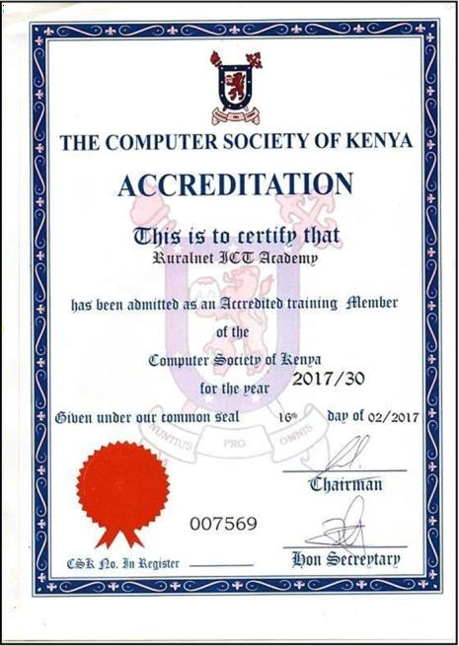
Fig 1: CSK LETTER Fig 2: CSK CERTIFICATE

Appendix 2. Marketing Samples
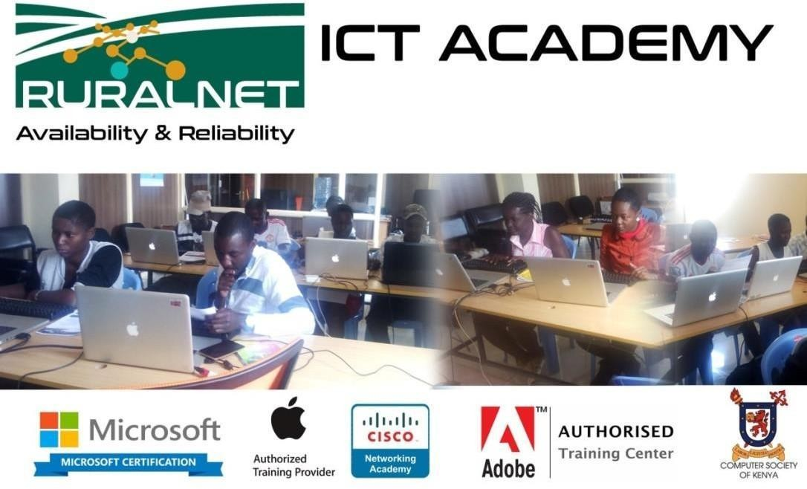

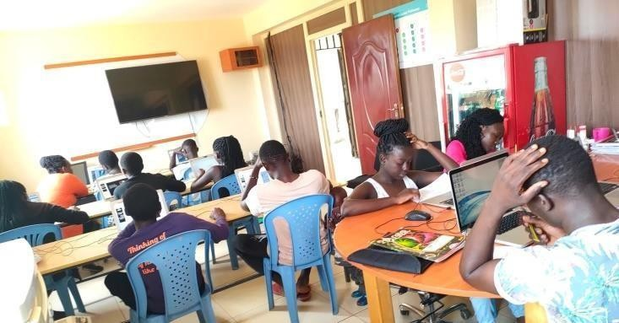
Fig 4: Class in session

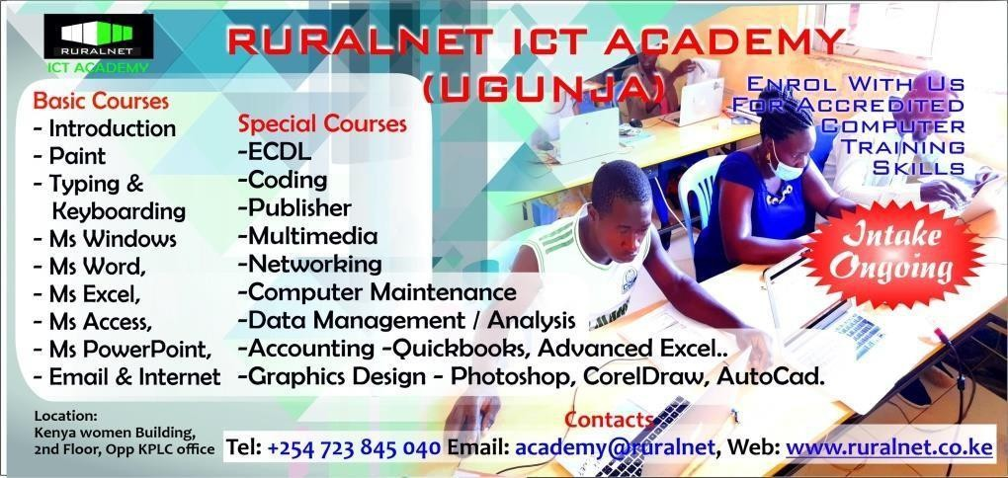
Fig 5: Advertisement

PLEASE INCLUDE 1 OR 2 PHOTOS OF WHEN THE STUDENT(S) RECEIVED A CERTIFICATE AT THE END OF THE TRAINING

